Bridging design prototypes (BDPs) - A design tool to research and resource sustainable, equitable, flexible learning
Gloria Gomez, University of Sydney Medical School

Abstract
To support digital access and equity, human-centred design (HCD) has been recommended to facilitate the construction of culturally sensitive, accessible, and flexible learning. The bridging design prototype (BDP) approach is an HCD method, used to advance novel educational practice in K-12 and distance higher education. BDPs are fully functional rapid prototypes of resources/technologies that educators accept to incorporate in real activities with their students. Early adoption of a BDP enables a classroom community to participate and play a critical role in a design process, which makes them suitable to investigate needs and emergent practices in a sustainable and respectful manner. This approach is comprised of six principles underpinned by concepts drawn from: human-centred product development, user-centred design, inclusive design, participatory design, and a theory for meaningful learning. The first set of principles help to understand who we are designing for and the second set of principles help to implement resource features. BDPs are useful in projects seeking community design, bottom-up adoption, decentring external designer participation, and enabling users to become designers. A walked through example on the implementation of a BDP is used to illustrate how this framework is used for prototyping resources that engage educators, students, and support staff in meaningful and engaging experimentations.

Keywords: bridging design prototypes, design tool, flexible learning, human-centred design, teachers as designers, co-creation of learning

To support digital access and equity, human-centred design (HCD) has been recommended to facilitate the construction of culturally sensitive, accessible, and flexible learning (Gomez et al., 2022). The bridging design prototype (BDP) approach is an HCD method, developed to advance novel educational practice (Gomez, 2010, 2020). BDPs are fully functional rapid prototypes of resources/technologies that educators accept to incorporate in real activities with their students. Early adoption of a BDP enables every community member to participate and play a critical role in a design process, which makes them suitable to investigate emergent practices sustainably and respectfully.
This approach is comprised of six principles (see figure 1) underpinned by seminal concepts drawn from: human-centred product development (Norman, 1999), user-centred design, inclusive design, participatory design (Keates & Clarkson, 2003; Norman, 2002; Sanders & William, 2002; Suchman, 1993), and a theory for meaningful learning (Ausubel et al., 1978). BDPs are experience prototypes (Coughlan et al., 2007) and provotypes (Mogensen, 1991). Experience prototypes emphasise experiential aspects while provotypes are used to provoke reaction and insights. The main difference between these also rapid prototypes is that BDPs must be fully functional rapid prototypes and experimentation should not require the presence of designers. By functional, it means all features should operate, and users should be able to implement them in real activities. But these are not necessarily minimum viable products, as the digital or tangible materials with which they are built could have a limited lifespan.
BDPs have been implemented to advance concept mapping in K12 (Cassata-Widera, 2009; Gomez, 2010; Kicken et al., 2016) as well as online academic study (Gloria Gomez et al., 2022) and the first-year student experience (Gomez & van der Meer, 2010) in higher education. A critical reflection (Gomez, 2020) on the work of Kicken et al. (2016) showed that BDPs might be useful in projects seeking community design, bottom-up adoption, decentring external designer participation, and enabling users to become designers (Lee, 2008). Speech therapists, counsellors, and teachers not only adapted my BDP for preschool concept mapping (Gomez, 2010) for teaching interactive language learning, but they also replaced it with a completely new design, a tool for the Interactive Whiteboard. This outcome showed that BDPs can enable teaching staff to design their own novel educational resources with little or no participation of an external designer and support Weiner et al.’s statement that “everybody who works in education is a designer” (2020, p. 781).
The following walked through example on the implementation of a BDP to support the first-year student experience was produced in 336 hours during a fixed-term contract. My aim was that academic and support staff could update and improve it with little or no expert design assistance.
The first set of BDP principles “bringing a multidisciplinary thinking team approach”, “achieving similar mental models” and “understanding prior knowledge and familiar interactions” helped to implement an HCD study to understand needs, wants, and context of the learning community. Primary and secondary data were collected via multiple sources: (1) student interviews on first-year experiences; (2) conversations with academics teaching first-year students and student note-takers; (3) conversations with student learning centre staff; and (4) review of secondary sources on academic self-efficacy (Bandura, 1986), self-directed learning and guided-discovery instruction (Novak, 1998; Piskurich, 2015), and a PhD thesis on first-year students making sense of the challenges and the teaching environment (van der Meer, 2008; van der Meer et al., 2010).
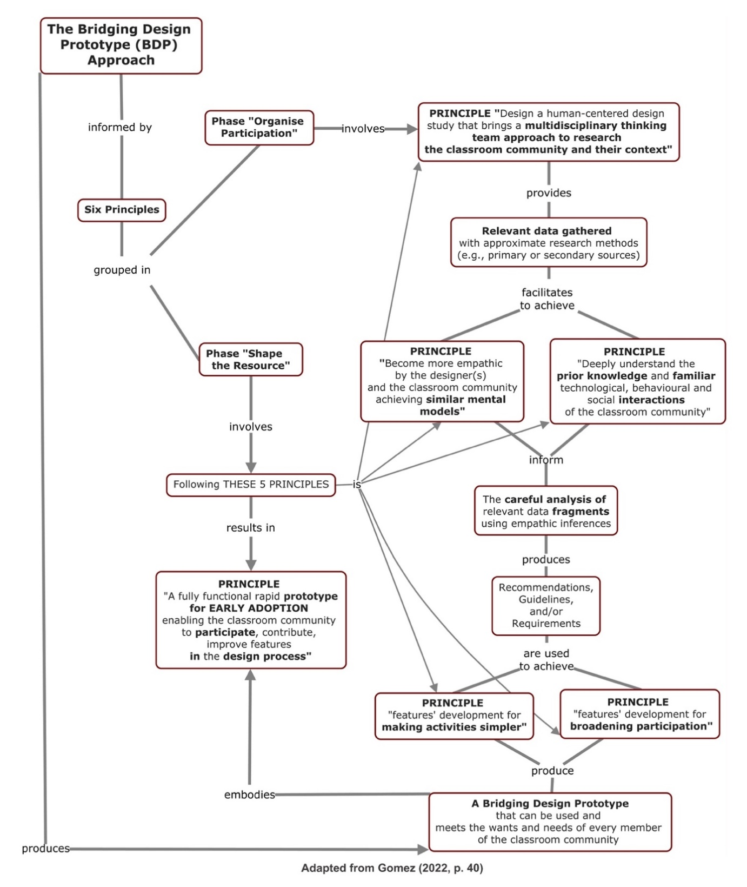
Figure 1: A step-by-step guide showing how the BDP principles are organised and interact with each other during the human-centred design process of an educational resource (Gomez, 2022).
A deep understanding of the prior knowledge as well as the familiar technological, behavioural and social interactions of students, academic and support staff was achieved through data gathering activities (conversations, interviews, attending tutorials, producing resources, etc.) and empathic inferences (Fulton Suri, 2003; Postma et al., 2012) of selected data fragments. My empathy and solidarity as a designer emerged from engaging meaningfully with students and staff, which helped lessen the gap between their mental models and mine during the development of suitable features for students (e.g., use student voice and guide students into self-teaching), academic and support staff (e.g., build on familiar technologies and approaches).
The second set of BDP principles “making activities simpler”, “broadening participation in the design process”, and “enabling participation in the design process” guided the implementation of features of self-guided online resources to help first year and pre-university students to orientate themselves to university study life. Based on data gathered on common needs and capabilities as well as familiar technologies, a decision was made to implement website and online resources with technologies that student advisors and support staff were proficient using, so they could carry out website and resource updates without external expert support. Today these resources will also have to comply with accessibility standards and address the needs of mature and disabled students.
The self-directed approach to learning (Novak, 1998; Piskurich, 2015) chosen for resource development required a slow introduction of the topics through small sets of goals on the aspects contributing to academic success: effective self-efficacy beliefs, necessary subskills, and appropriate social and physical conditions. The literature review and conversations with students and staff helped identify topics for the website: high school vs university experience, what to expect from lectures, seminars, tutorials and laboratories, university study strategies, subject specific skills, setting realistic goals, future time perspective, study habits and learning styles, preparing for assessment, seeking help, motivation, study and social life, mental well-being. A webpage per topic introduced how-to information in the form of an interview, video, quiz, and/or online tutorial. Content was created using magazine writing style: informative, short, concise, as if someone was talking to you personally.
The approach taken to resource production made it possible to co-create. Academic and support staff produced how-to videos (e.g., doing oral presentations, writing skills, etc.). Short videos were produced by more senior students explaining how-to take lecture notes or sharing aspects of their first-year experience. Two senior students were recruited to interview their peers using questions developed based on identified topics. Motivation and retention of diverse students (Cook & Cook, 2023) require changes in how technology is used (Lai & Bower, 2020), curriculum is designed (Bovill & Woolmer, 2019; Vaughan et al., 2023), and students understood (Daellenbach et al., 2022). The BDP approach provided a framework for prototyping resources that engaged educators, students, and support staff in experimentations that had the potential for meaningful learning and foster connection. This walked through example will be used as a starting point in an asynchronous activity inviting educators to become designers and experiment with BDPs of novel resources for sustainable, equitable, and flexible learning.

References
Ausubel, D. P., Novak, J. D., & Hanesian, H. (1978). Educational psychology: A cognitive view (2nd ed.). Holt, Rinehart and Winston.
Bandura, A. (1986). Social foundations of thought and action: A social cognitive theory. Prentice Hall.
Bovill, C., & Woolmer, C. (2019). How conceptualisations of curriculum in higher education influence student-staff co-creation in and of the curriculum. Higher education, 78(3), 407-422. https://doi.org/10.1007/s10734-018-0349-8
Cassata-Widera, A. E. (2009). Concept mapping with young children: From representation to metacognition. VDM Verlag.
Cook, J., & Cook, J. (2023). Facilitating active learning in an asynchronous environment using simulations. In E. Meletiadou (Ed.), Handbook of research on redesigning teaching, learning, and assessment in the digital era (pp. 262-286). IGI Global. https://doi.org/10.4018/978-1-6684-8292-6.ch014
Coughlan, P., Fulton Suri, J., & Canales, K. (2007 ). Prototypes as (design) tools for behavioral and organizational change: A design-based approach to help organizations change work behaviors. The Journal of Applied Behavioural Science, 43 (1), 122-134. https://doi.org/10.1177/0021886306297722
Daellenbach, R., Kensington, M., Maki, K., Prier, M., & Welfare, M. (2022). A networked distributed model for midwifery education. In S. Chan & N. Huntington (Eds.), Reshaping vocational education and training in Aotearoa New Zealand (pp. 335-354). Springer International Publishing. https://doi.org/10.1007/978-3-031-12168-5_18
Fulton Suri, J. (2003). Empathic design: Informed and inspired by other people’s experience. . In I. Koskinen, K. Battarbee, & T. Mattelmäki (Eds.), Empathic design: User experience in product design (pp. 51-58). Edita IT Press.
Gomez, G. (2010). Enhancing autonomy, meaning negotiation, and active inquiry in preschool concept mapping. In P. Lupion-Torres & R. C. Veiga-Marriott (Eds.), Handbook of research on collaborative learning using concept mapping (pp. 383-401). Information Science Reference, IGI Global.
Gomez, G. (2020, 4 June, 2020). Bridging design prototypes & autonomous design. Proceedings of Pivot 2020: Designing a World of Many Centers
Gomez, G. (2022). The bridging design prototype approach: Strengthening the role of design as a strategic resource in small organisations. In E. Erturk & B. Otinpong (Eds.), CITRENZ 2022: Proceedings of the 13th Annual Conference of Computing and Information Technology Education and Research in New Zealand (pp. 37-47). https://citrenz.org.nz/citrenz/2022-proceedings/
Gomez, G., Daellenbach, R., Kensington, M., Davies, L., & Petsoglou, C. (2022, 7 - 8 March, 2022). Students and teachers co-designing media-rich document resources in an asynchronous virtual personal learning environment. Proceedings of INTED2022 Conference, https://iated.org/concrete3/view_abstract.php?paper_id=93957
Gomez, G., Jones, H., & Birt, J. (2022). Accessible content and digital equity. In C. Campbell, C. Porter, D. Logan-Fleming, & H. Jones (Eds.), Scanning the Ed Tech Horizon: The 2021-2022 Contextualising Horizon Report (pp. 26-29). ASCILITE. https://ascilite.org/wp-content/uploads/ContextualisingHorizonReport2122f.pdf
Gomez, G., & van der Meer, J. (2010, 24-26 November, 2010). Getting ready for Otago: Online guided discovery resources to enhance the first year experience. TERNZ Conference 2010: Tertiary Education Research New Zealand (Book of Abstracts), Dunedin, New Zealand.
Keates, S., & Clarkson, J. (2003). Countering design exclusion: An introduction to inclusive design. Springer.
Kicken, R., Ernes, E., Hoogenberg, I., & Gomez, G. (2016). Improving the teaching of children with severe speech-language difficulties by introducing an authoring concept mapping kit. In A. J. Cañas, R. Priit, & J. Novak (Eds.), Innovating with Concept Mapping: 7th International Conference on Concept Mapping, CMC 2016 September 5-9, 2016, Proceedings (Vol. 635, pp. 112-127). Communications in Computer and Information Science, Springer https://link.springer.com/chapter/10.1007/978-3-319-45501-3_9
Lai, J. W. M., & Bower, M. (2020). Evaluation of technology use in education: Findings from a critical analysis of systematic literature reviews. Journal of computer assisted learning, 36(3), 241-259. https://doi.org/10.1111/jcal.12412
Lee, Y. (2008). Design participation tactics: The challenges and new roles for designers in the co-design process. Co-design, 4(1), 31-50.
Mogensen, P. (1991). Towards a provotyping approach in systems development. Scandinavian Journal of Information Systems, 3, 31-53 http://iris.cs.aau.dk/tl_files/volumes/volume04/no1/02_mogensen_p31-53.pdf
Norman, D. A. (1999). The invisible computer: Why good products can fail, the personal computer is so complex, and information appliances are the solution. MIT Press.
Norman, D. A. (2002). The design of everyday things (2002 ed.). Basic Books. (1988)
Novak, J. D. (1998). Learning, creating and using knowledge: Concept maps as facilitative tools in schools and corporations. Lawrence Earlbaum Associates.
Piskurich, G. M. (2015). Rapid instructional design: learning ID fast and right, third edition (3rd ed.). Wiley.
Postma, C. E., Zwartkruis-Pelgrim, E., Daemen, E., & Du, J. (2012). Challenges of Doing Empathic Design: Experiences from Industry. International journal of design, 6(1), 59-70.
Sanders, E., & William, C. (2002). Harnessing people's creativity: Ideation and expression through visual communication. In J. Landford & D. McDonagh (Eds.), Focus groups: Supporting effective product development (pp. 137-148). CRC Press.
Suchman, L. (1993). Foreword In D. Schuler & A. Namioka (Eds.), Participatory design: Principles and practices (pp. vii-xii). Lawrence Erlbaum Association.
van der Meer, J. (2008). Mapping first semester challenges: First-year students making sense of their teaching and learning environments (Publication Number 9926478518601891) [Thesis - Doctoral, University of Otago]. https://hdl.handle.net/10523/540
van der Meer, J., Jansen, E., & Torenbeek, M. (2010). 'It's almost a mindset that teachers need to change': first-year students' need to be inducted into time management. Studies in higher education (Dorchester-on-Thames), 35(7), 777-791. https://doi.org/10.1080/03075070903383211
Vaughan, N. D., Dell, D., Cleveland-Innes, M., & Garrison, R. (2023). Principles of blended learning: Shared metacognition and communities of inquiry. Athabasca University Press. https://doi.org/10.15215/aupress/9781771993920.01
Weiner, S., Warr, M., & Mishra, P. (2020). Fostering system-level perspective taking when designing for change in educational systems. TechTrends, 64(5), 779-788. https://doi.org/10.1007/s11528-020-00529-w

