Audit of Statutory Urgent Treatment at a High Security Hospital
Andy Bickle1, Tarek Abdelrazek2, Anne Aboaja3 & Kim Page4
Introduction
Section 62 of the Mental Health Act 1983 (‘the Act’) allows urgent treatment for mental disorder to be given without patient consent, and overrides the requirement for the procedural safeguards provided for within sections 57 and 58. “It is not applicable to any treatment that does not come within the remit of either section 57 or section 58”5. This statutory ‘urgent treatment’ provision applies only to patients liable to be detained under the long-term sections of the Act6. Under s62, treatment may be given:
- (a) which is immediately necessary to save the patient’s life; or
- which (not being irreversible7) is immediately necessary to alleviate serious suffering by the patient; or
- which (not being irreversible or hazardous8) is immediately necessary to alleviate serious suffering by the patient; or
- which (not being irreversible or hazardous) is immediately necessary and represents the minimum interference necessary to prevent the patient from behaving violently or being a danger to himself or to others.
Section 62 can also be applied where a responsible medical officer considers that discontinuance of the treatment already in progress would cause serious suffering to the patient9. Such a situation might occur, for example, when a patient withdraws their consent but it is deemed necessary for treatment to continue until a second opinion can be obtained.
It can be seen that this section lifts the legal requirement to obtain a patient’s consent or the authorisation of a SOAD for treatment with medication after the first three months, or for treatment with ECT at any time. It can also provide a legal basis, where immediately necessary, to provide the type of treatments described in section 57 which otherwise require both consent and a second opinion (although given the nature of treatments - in practice only psychosurgery - covered by section 57, the circumstances in which such power would be invoked are “difficult to envisage”10).
The powers of urgent treatment provided under s.62 will be essentially retained following the amendments made to the Act by the Mental Health Act 2007, although their application in the case of ECT will be restricted to situations where treatment is immediately necessary to save life or, not being irreversible, to prevent serious suffering (i.e. the criteria under s.62(1)(a) or (b)). By virtue of a new s.62A, urgent treatment powers under s.62 will be applicable to patients recalled to hospital from supervised community treatment (SCT), and to such patients whose SCT status is revoked. Emergency treatment powers over SCT patients who have not been recalled to hospital will not apply where the patient has given a capable refusal of consent.11 It appears that existing standards for best practice (outlined below) will remain authoritative as they are all retained in the revised Code of Practice published by the Department of Health in May 2008.
These standards are set out in the current Code of Practice12. They concern the proper application of the section, patient consent and proper documentation. The Mental Health Act Commission has given additional guidance regarding second opinions. No statutory forms are provided to document the use of section 6213. Instead, the Code recommends that hospital managers devise their own forms14. Little audit or research on the proper use of statutory urgent treatment has been reported in the literature. Johnson & Curtice found in their general psychiatry service that section 62 was used exclusively to authorise ECT15. In contrast, Haw & Shanmugarutnum found that in a large hospital including patients detained under Part III of the Act in conditions of low and medium security, this section was used mostly to give medication16. Neither of these audits was reported in detail and so compliance with all of the available standards is not known. In Scotland, Nelson et al17 audited notification documentation relating to treatment given under section 98 of the now repealed Mental Health (Scotland) Act 1984 (which was equivalent to section 58 of the Mental Health Act 1983). They found that regular medication was stated in over 90% of cases, but ‘as required’ medication was less well recorded, suggesting perhaps that psychiatrists are less good at documenting unplanned treatment.
The aim of the audit which is the subject of this article, was to measure the use of statutory urgent treatment at one of England’s three high security hospitals (Rampton Hospital) against the standards set out in the Code and by the MHAC. Rampton Hospital is a large hospital which averaged around 400 beds during the audit period and has a catchment area of approximately one third of England. The hospital accommodates patients who suffer from a wide range of mental disorders, having directorates for mental illness, learning disability, personality disorder, women and (from 2004) ‘Dangerous and Severe Personality Disorder’. All patients are detained under the Mental Health Act 1983. It was submitted that the proper use of statutory urgent treatment is important to Rampton Hospital as an institution which accommodates patients presenting with the highest security needs owing to their risk to others.
Method
The study audited all episodes of urgent treatment authorised by section 62 at Rampton Hospital over nearly 5½ years between January 1st 2000 and June 1st 2005. A list of all episodes within the audit period was generated by the Information Governance Department at Rampton Hospital. This was based on their log of section 62 documentation sent to them as per hospital procedure. A data collection tool was designed for the task. Data was collected from medical records and Mental Health Act Office files. Records were retrieved from the Rampton Hospital Archive where necessary. Relevant information was found on Section 62 forms, other MHA-related paperwork (forms 38 & 39), the continuous healthcare record and medication cards. It was assumed that any second opinion given within ten days of statutory urgent treatment had been requested as a result of that treatment episode.
Standards
Three audit standards were extracted from the Code of Practice (1999):
- Section 62 should only be applied to those patients and types of treatments provided for in sections 57 and 58 of the Mental Health Act (1983).18
- The patient’s consent should be sought for all proposed treatments which may lawfully be given under the Act. The interview at which such consent was sought should be properly recorded in the medical notes.19
- Every time urgent treatment is given under section 62, the patient’s RMO or the doctor for the time being in charge of the patient’s treatment should complete a form giving details of:
- the proposed treatment;
- why it is of urgent necessity to give the treatment;
- the length of time for which the treatment was given.20
A further standard was provided by the Mental Health Act Commission:
Where section 62 is invoked, a request should generally simultaneously be made for a second opinion, so that repeated use does not arise.21
It was expected that every urgent treatment episode would be compliant with standards 1–3. With regard to standard 4, it was accepted that a need for a second opinion would not arise from every urgent treatment episode, but reflecting the assertion that a request should generally be made it was expected that this should happen in a majority of episodes.
Results
It was found that urgent treatment was given at Rampton Hospital under section 62, on 107 occasions between January 2000 and June 2005. The results for each audit standard were as follows:
Standard 1
The type of treatment authorised by section 62 was mostly medication:
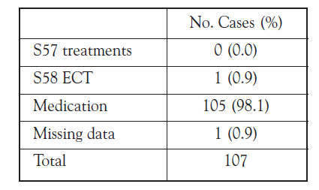
Tab. 1 Types of treatment given under section 62
Assessing adherence to this standard involved several considerations. The standard insists that section 62 should only be applied to those patients and types of treatments provided for in sections 57 and 58 of the MHA 1983. All patients at this hospital are detained under long sections of the Act and thus potentially liable to this section. However, 6% (6/107) of episodes involved patients for whom no evidence could be found of having yet been treated with medication for mental disorder and so could potentially have been given medication under the authority of section 6322. In a further 7% of episodes (7/107), data were missing.
Whether or not the prescribed medication was treatment for a mental disorder, was considered. This assessment was not straightforward as some medications for mental disorders are also indicated for other disorders23. However, most of the medications that were used do not have common physical health indications. It was concluded that in only one episode was medication for a physical disorder given under s.62. Elsewhere, in only one case was section 62 used to authorise ECT.
In summary, we found evidence that standard one was met in 92% of episodes for which data was available.
Standard 2
All types of medical record were scrutinised for evidence that the patient’s consent had been sought. The findings were as follows24:

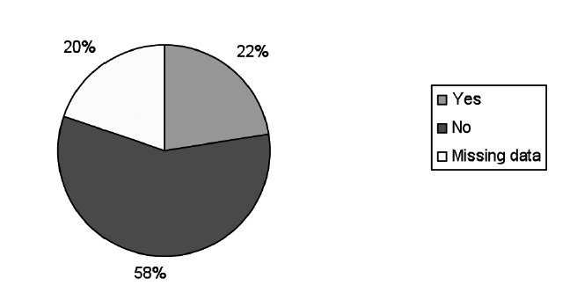
Fig. 1 Was there evidence of an interview at which consent was discussed?
Of the cases for which data was available, there was evidence of an interview at which consent was discussed in only 27% (24/88) of cases.
Standard 3
It was found in the large majority of cases that details of treatment, and a reason why it was of urgent necessity, was recorded. In far fewer cases (little more than a third) the length of the treatment was given:
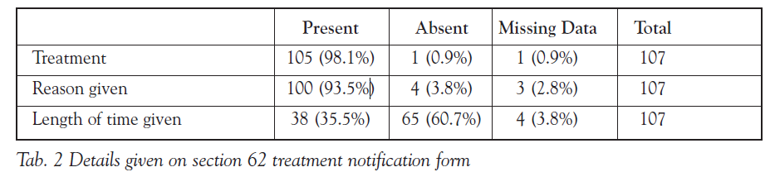
In nearly all cases for which data was available (99%), the form had been completed by a doctor. One form had been completed by a member of nursing staff. Most commonly it was completed by the patient’s responsible medical officer (53.3%). It was not possible to ascertain whether in the remaining cases, the doctor was definitely the doctor for the time being in charge of the patient’s treatment, but in most cases it appeared to be the on-call duty doctor, whom it was felt met that description.
Standard 4
It was found that a second opinion had been requested after a small majority (49/94 = 52.1%) of episodes for which data was available. In a further 13 cases it was not possible to form a view as to whether or not a second opinion had been requested, owing to missing data.
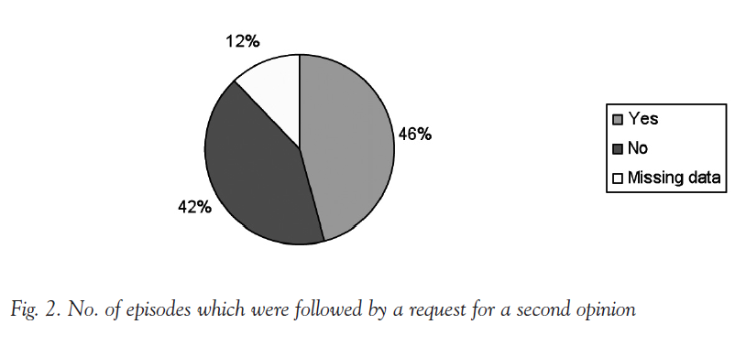
Further Finding
The reasons given for the urgent necessity of treatment as per the statutory provisions were reviewed. As might be expected, section 62 was most commonly invoked to prevent the patient behaving violently or being a danger to himself or others:
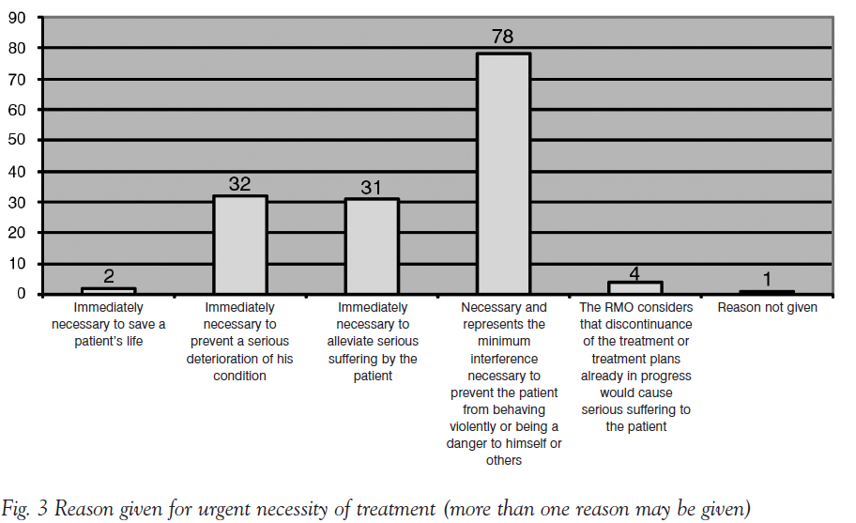
In only a handful of episodes, did RMOs exercise their power to use section 62(2) so as to continue with a treatment plan pending compliance with section 57 or section 58.
Conclusions
We conclude that the provisions for statutory urgent treatment for mental disorder were generally being applied at Rampton Hospital to give appropriate treatments25 to appropriate patients and the basic details of treatment were being documented. Therefore, it is our view that standards 1 and 3 were largely satisfied. We found that doctors did not routinely demonstrate that consent had been sought, and so practice in this regard fell well short of standard 2. We also note that those detailing urgent treatment did not outline the length of time for which treatment was to be given. We speculate that this may be because this standard as derived from the Code does not accord well with clinical practice inasmuch as it is phrased in the past tense as if to capture the entire treatment episode, when in fact this form is usually completed at the beginning of an episode of urgent treatment. Finally, we found that around half of episodes stimulated a second opinion request, suggesting that standard 4 was close to being met.
Overall, we observe that episode details which were prompted for specifically by the existing notification documentation were well recorded and details which were not prompted for specifically were not well recorded, either on the notification form or elsewhere in the clinical records. For example, the reason for urgent treatment was requested on the documentation form, but confirmation that consent had been sought was not. Similarly, a prompt for the type of treatment given was included on the form, but did not go so far as to ask for the length of treatment. This correlation between well-recorded data and the content of the data collection form is not surprising, but in our view does emphasise the importance of well-structured and fail-safe data collection systems.
Audit Cycle – The Next Step
In keeping with the belief that audit should be an ongoing process or cycle enabling continual improvement, we implemented interventions to improve the quality of section 62 usage. Most importantly, we redesigned the notification documentation so it included specific prompts for every piece of information required to meet the audit standards. For example, to make the recording of consent more user-friendly, we introduced a list of tick box options to document that an attempt had been made to obtain consent and the reason why this had not been successful. In addition, we presented our findings locally at a meeting of Rampton Hospital doctors and at a national meeting of forensic psychiatrists. The new notification documentation has now been in use for over a year and later in 2008 we will repeat the audit to measure its effectiveness.
Discussion
We believe this project was ambitious in scale, auditing as it did the use of section 62 within the entire patient population of a high security hospital for more than five years. There is little in the literature with which our results can be directly compared. Of interest, our finding that section 62 was being used almost entirely to administer medication accorded with that of Haw & Shanmugarutnum26, and not with Johnson & Curtice27 who in contrast found it was only used to authorise ECT. An explanation for this might be that the former audited a population which contained forensic patients and so was more akin to our own. Their sample is likely to have exhibited higher rates of severe and enduring mental disorder and lower rates of depression and acute suicidality than would be found in a general psychiatric setting.
Our main findings demonstrated that psychiatrists showed mixed ability at complying both with secondary legislation and guidance from the Mental Health Act Commission. However, when supported by structured information governance systems, their performance was, in our view, good. We hope that we have helped to improve compliance by introducing better notification documentation. However this finding does, perhaps, suggest there ought to be a statutory data collection vehicle for section 62 treatment as there is for other sections of the Mental Health Act, and that this should not be left to local hospital managers to design. Probably the worst recorded was information as to whether consent had been sought. As practising psychiatrists, we can see that where urgent treatment is being considered, the clinical situation is likely to be one where seeking consent is particularly difficult. One response to criticism on this issue may be that the patient’s mental state was so disturbed that any serious attempt would have been futile and may even have delayed treatment without any realistic prospect of benefit. Nevertheless, we feel that it is important to document this as the reason why consent had not been obtained, and our new documentation provides for this.
There were several limitations to this audit. Firstly, we were reliant on a list generated from records returned to a central office for detection of statutory urgent treatment. This may have introduced a sampling bias as there may have been something different about urgent treatment episodes which were not reported in this way (although all should have been reported). For example, episodes not reported to the central office may have been less well documented. From our consultations with stakeholders at both ends of this process (both ward staff and information governance staff) we feel reasonably reassured that the practice of notification was well-established and understood. We feel we have to accept this limitation owing to the practical difficulties of collecting the data for an audit on such a scale in this setting, but we are mindful that the results obtained may be unrepresentative to some degree.
Secondly, there were problems inherent in collecting data respectively from such a long sample period. Some data was missing (the exact percentage varied according to each piece of information as they were available from different sources such as multidisciplinary record, drug card etc). Most of the missing data was accounted for by entire records being missing. It appeared that this usually occurred when the patient had been transferred to another high security hospital. This was less often the case when the patient had been transferred to a less secure hospital or discharged to prison or elsewhere. Therefore, it is possible that the missing data represented patients who were more mentally disturbed and were in need of a high security hospital environment in the longer term. Other problems with collecting data highlighted deficits in recording the requisite information on existing documentation. For example, there was no space or prompt provided to comment on consent. This meant that we had to review all contemporaneous available clinical information to see if it had been recorded elsewhere. This made data collection less robust and increased the possibility of not finding information.
Thirdly, the difficulty in ascertaining when records were missing may have led to us overestimating the number of patients who had not previously received medication for mental disorder, and thus could have been treated without their consent under the three month rule without resorting to section 62. For example, in reviewing the extensive records we may have concluded there was no evidence that they had received medication before, but there may have been missing documentation of which we were unaware which showed that they had. If there were indeed such cases we will have underestimated the number of episodes in which this standard was met. However, as compliance with this standard was already good at over 90% we do not believe any error would significantly alter our conclusions.
Fourthly, with respect to standard four, we inferred that a request for a second opinion had been made if one was given within ten days. We had no means of assessing directly whether a request had in fact been made to the Mental Health Act Commission. We hope that any request would have been met within ten days, but it is possible that some opinions took longer to arrange. Conversely, it is possible that a visit from a second opinion doctor had already been arranged before section 62 treatment took place, and so had not been precipitated by use of the section.
We acknowledge these limitations, but despite these shortcomings we believe that valid observations can be made and drawn upon to improve adherence to legislation. Furthermore, we are confident we have taken important practical steps to enhance our own practice. The available evidence suggests that the audit standards we adopted will continue to form the basis of guidance on statutory urgent treatment after the amendments to the Act by the Mental Health Act 2007 come into force. Therefore, we believe that the audit cycle started here will be relevant for the foreseeable future. We look forward to repeating this audit and assessing the impact of our interventions. Our next audit should be amended slightly to acknowledge the amendments made to s. 62 in respect of ECT. Similar audits completed in settings receiving patients recalled from the community under community treatment orders should include this type of patient within their sample.
The authors would like to thank Dr Emmet Larkin (Consultant Forensic Psychiatrist & Associate Medical Director, Rampton Hospital), Joanne Gleaden and Julie Smith (Health Effectiveness & Audit Team, Rampton Hospital), Lynn Lamb, Beth McCarthy and Keith Allen (Information Governance, Rampton Hospital) and Linda Fields (Mental Health Act Administration Team, Rampton Hospital) for their kind and frequent assistance with this project.

1 Specialist Registrar in Forensic Psychiatry, East Midlands Centre for Forensic Mental Health, Arnold Lodge, Cordelia Close, Leicester.
2 Associate Specialist in Forensic Psychiatry, Rampton Hospital, Retford, Nottinghamshire.
3 Specialist Registrar in Forensic Psychiatry, Rampton Hospital, Retford, Nottinghamshire.
4 Consultant Forensic Psychiatrist, Rampton Hospital, Retford, Nottinghamshire.
5 Jones R. (2006) Mental Health Act Manual (10th Ed.) Sweet & Maxwell: London, page 332.
6 It does not apply to patients liable to be detained under ss 4, 5(2), 5(4), 35, 37(4), 135, 136 or patients who have been conditionally discharged and not recalled. See s. 56 MHA 1983.
7 Meaning, at s62(3), “if it has unfavourable irreversible physical or psychological consequences”.
8 Meaning, at s62(3), “if it entails significant physical hazard”.
9 S62(2).
10 Jones R. (2006) Mental Health Act Manual (10th Ed.) Sweet & Maxwell: London, page 333.
11 MHA 2007, s.64B(3), 64G(5)-(7), and 64G
12 Dept of Health & Welsh Office (1999) Code of Practice. Mental Health Act 1983. London: HMSO, see chapters 1, 15 and 16.
13 This is in contrast to forms 38 & 39 which are provided or the documentation of consent and treatment decisions relating to sections 57 & 58 of the Act.
14 At para 16.41
15 Johnson I & Curtice M (2000) Use of Section 62 in clinical practice. Psychiatric Bulletin 24: 154.
16 Haw C & Shanmugarutnum R (2000) Use of Section 62 in clinical practice. Psychiatric Bulletin 24: 276.
17 Nelson D, Wright M, Walsh I, Moody K. & Beveridge L. (2003) The Use of Consent-to-Treatment Forms at the State Hospital: An audit in 1996 and 2000. Medicine, Science and the Law, 43(2), 132-135.
18 Code of Practice Mental Health Act 1983, para 16.2.
19 Ibid, para 16.4.
20 Ibid, para 16.41.
21 Mental Health Act Commission (1987) Second Biennial Report (1985-1987). London: HMSO, para 7.6.
22 “The consent of a patient shall not be required for any medical treatment given to him for the mental disorder from which he is suffering, not being treatment falling within section 57 or 58 above, if the treatment is given by or under the direction of the responsible medical officer”
23 Many mood stabilizing medications are also anti-epileptics and some antidepressants are given for neuropathic pain, to name but two examples.
24 We required specific reference to an attempt to obtain consent and did not accept it had been made if merely reference to a meeting with the patient proximal to the treatment had been made, even when the patient was described as “unco-operative” or in similar terms.
25 We mean this in a legal sense; this project was not designed to assess clinical judgment in individual treatment episodes.
26 Haw C & Shanmugarutnum R (2000) Use of Section 62 in clinical practice. Psychiatric Bulletin 24: 276.
27 Johnson I & Curtice M (2000) Use of Section 62 in clinical practice. Psychiatric Bulletin 24: 154.

