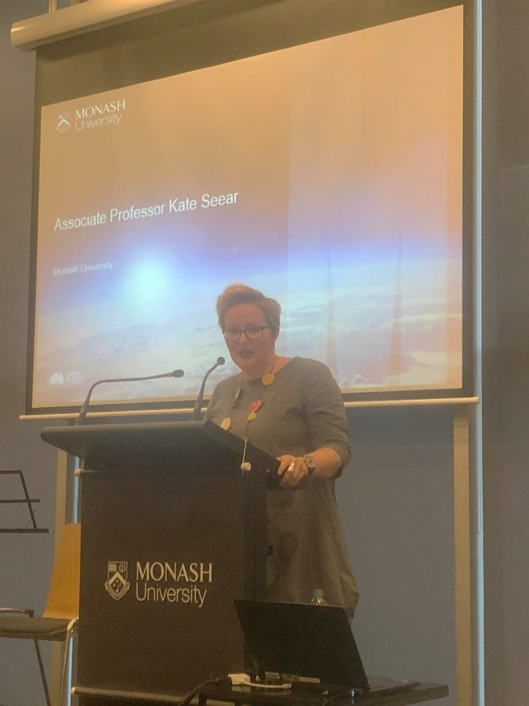**ADRIAN EVANS FESTSCHRIFT SPECIAL ISSUE**

**Editorial**

**Kate Seear, Monash University, Australia**

In November 2018, Monash University had the privilege of hosting the annual IJCLE conference. The conference has long given clinicians from across the world an opportunity to come together and share findings from research into clinical legal education. The conference brings more junior and senior clinicians together, too, and allows clinicians to share stories and ideas and to deliberate about and debate problems pertaining to the clinics they work in.

Professor Adrian Evans is one of the true stalwarts of clinical legal education, and has been a regular attendee at the conference over many years. Many of those familiar with the work of IJCLE will also be familiar with Adrian’s enormous contribution to the fields of clinical legal education and legal ethics over the last four decades. In 2018, Adrian announced he would be retiring from academia. Somewhat serendipitously, Adrian’s retirement coincided with Adrian’s own university (Monash) hosting the IJCLE conference, and thus gave us an opportunity to celebrate Adrian’s work with colleagues from across the globe.

This celebration took the form of a special event (a ‘festschrift’) over one afternoon, before the commencement of the IJCLE conference. The event was a mix of personal and professional reflections on Adrian’s life and career, offered by a range of colleagues. It was also an event of varying emotions and formats. There was serious, academic reflection on Adrian’s contributions to scholarship, alongside musical tributes and jokes, and reflections on behalf of his family, delivered by Adrian’s partner Maria Bohan. The event also coincided with an address from the Dean of the Monash faculty of Law, Professor Bryan Horrigan, in which he spoke about Adrian’s crucial role in the establishment of the Faculty’s clinical guarantee, and where he announced publicly for the first time that Adrian would be appointed as an Emeritus Professor.

Professor Elaine Hall invited us to turn the festschrift event into a special issue of the IJCLE journal in honour of Adrian. This special issue contains photographs from the day and contributions – in a range of forms – from all of those who spoke at the event, including remarks from Adrian himself.